QUBIO User Manual 12-2-2008 version

Overview 1
Menu 2
Hardware Configuration 3
Settings 5
Protocol Dialogue 6
Session Configuration Dialogue 10
Session Dialogue 11
Session Dialogue 11

Overview
QUBIO is a program to acquire and generate analog and digital data using National Instruments MX series hardware. Acquired data is stored in a .qdf file which is a tree based format compatible with the GEM or QUB ion channel analysis programs. QUBIO was created as a utility for physiology researchers at the Univeristy of Buffalo, but it is a general purpose utility, possibly suited for other tasks. The primary goal of this program is to generate and acquire data easily, quickly, with as little possibility of data glitches or data loss as possible. The scope of this program is intentionally limited to help realize these goals.
Use of the program is primarily through the session interface, which provides the ability to control generation signals and monitor acquisition signals. Additionally, there are hardware configuration, protocol building, gain settings tables, feedback configurations and program settings dialogues which are used to prepare the sessions. Each of these are detailed separately below, but it is useful to keep in mind that the central focus is the session, and the other items are preparatory to it.
QUBIO requires a computer running windows 98 or later, National Instruments NIDAQ MX version 7.3 or later and a National Instruments MX series acquisition card. Primary testing has been on a Pentium 4 2ghz, Windows XP, NIDAQ 7.4, PCI6229 card. A fairly fast computer, particularly the hard disk, is required since QUBIO streams the data directly to the disk with little buffering.
The program consists of one file, QUBIO.EXE. There are no libraries, custom controls, or other files. Configuration settings are stored in a file named QUBIO.CFG which is created the first time the program is run. If you wish to move the QUBIO.EXE file after using it, you should also copy the QUBIO.CFG file. If you wish to have multiple configurations, you should create multiple folders and place a copy (not a shortcut) of the QUBIO.EXE file in each folder. Some settings are stored in the registry and will be shared among all installations.
Questions, comments, support requests should be directed to the email contact address listed on the UB website, http://www.gem.buffalo.edu.

Menu
The following are the QUBIO menu options and a brief description of each items function :
File Session New Start a new session.
Open Load a previously saved session file.
Protocol New Open the protocol editor with a new protocol.
Open Open a previously saved protocol file.
Gain Tables New Create a new gain table
... A list of the existing gain tables follows.
Hardware Con New Create a new hardware configuration
... A list of the existing hardware configurations follows.
Feedback Con New Create a new feedback configuration.
... A list of the existing feedback configurations.
Digital Protoc New Open the digital protocol editor with a new protocol.
Open Open a previously saved digital protocol file.
QUBIO Settings Change the software default settings
Close Close the currently active session/protocol window.
Exit Exit QUBIO.
View Error Window Open the error display window.
Help About The ‘splash’ screen, contains the QUBIO version number.

Hardware Configuration
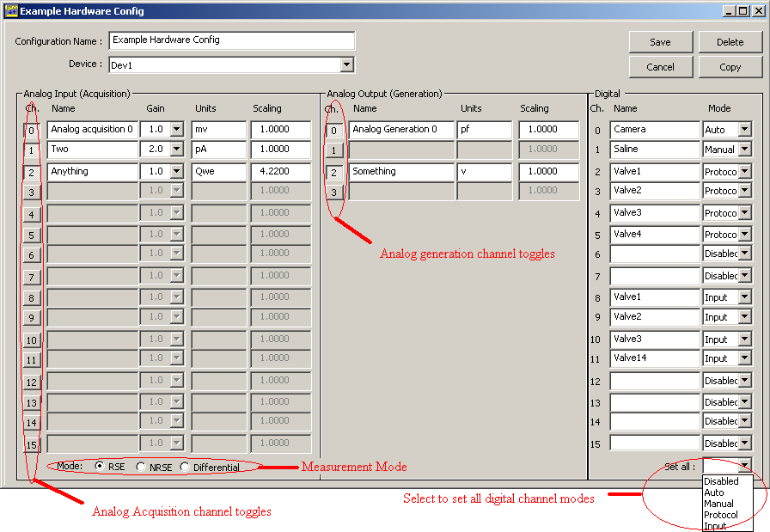

The hardware configuration identifies which ports on your acquisition hardware you wish to utilize. You can have multiple configurations, which are selected using the configuration name you provide. QUBIO will allow the use of the first 16 analog acquisition ports, first 4 analog generation ports, and first 16 digital lines on a card, though your hardware may have additional ports.
“Configuration Name” – Provide a unique name for the configuration. This name will be added to the list of available hardware configurations you select from when starting a new session.
“Device” – If you have more than one NIDAQ mx series card installed in your computer, here you can select which device to configure. A single session can utilize only one device, so you will need multiple sessions active to control multiple devices.
[Delete] – If you are modifying an existing configuration, the [Delete] button will be available.
[Save] – Save the configuration changes and close the dialogue.
[Cancel] – Close the configuration dialogue without saving changes.
[Copy] - If you are modifying an existing configuration, the [Copy] button will be available. This will make a copy of the configuration being modified when you [Save] the changes.

Analog Input / Output : The following descriptions apply to the 16 (or fewer) acquisition channels and 4 (or fewer) generation channels rows of controls :
“Channel” – The buttons toggle whether a particular port will be available in the session. When toggled off, the controls for that row are disabled.
“Name” – Provide a name which will be displayed on the session panel for this channel. This has no effect on the acquisition session.
“Gain” – (acquisition channels) Select the gain which will be applied to the analog signal being sent to the computer prior to the conversion to a digital value. For optimal signal resolution, use the highest gain ( multiplier ) which will allow the range of your input signal you are interested in to fall within the limits of your cards input range ( usually -10 to +10 volts or -5 to +5 volts ). If you control the level of the signal externally, set the gain to 1.0 and use your external amplification to produce a desirable range. There are a limited number of gain settings which depend on the acquisition card capabilities.
“Units” – Provide the Units or other text which will be displayed for this channel. This has no effect on the acquisition session.
“Scaling” – For acquisition, a multiplier which is applied to the signal after it has been digitized to change the scale of the values written to a data file. For Generation, a multiplier which is applied to the protocol values prior to writing to the output (digital to analog) port.

Digital : Each digital line has a name and mode setting. The name is used as a label in the session dialogue and when recorded in the data file. Digital line modes can be set to Disabled, Auto, Manual, Protocol, or Input.
“Auto” and “Manual” mode lines buttons will appear as a pushbutton on the session dialogue. “Manual” digital lines can be toggled on and off. When recording, these events will appear as list items labeled with the line name and ‘On’ or ‘Off’ as appropriate. “Auto” lines are set high when clicked and are automatically set low one sample later. In the recorded data file these events appear as list items labeled with the line name.
“Protocol” mode lines also have appear as puchbuttons which function the same as the “manual” lines. Additionally, during generation tasks, a digital pulse protocol is written to the port.
“Input” mode lines will be acquired for the session display and added as a recorded channel in the data file.

Settings
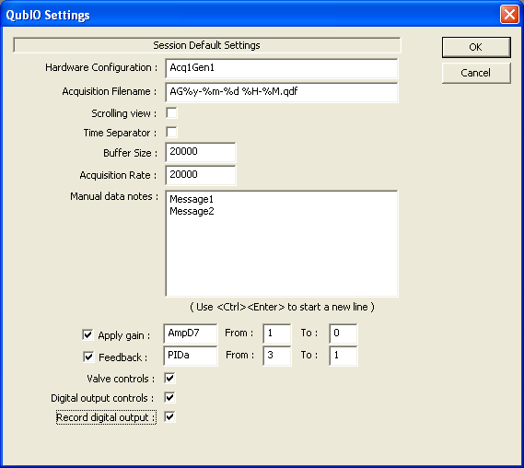

This dialogue allows you to change several default values used by QUBIO for new sessions. Change the desired settings and select [OK] to save or [Cancel] to discard changes.
“Hardware Configuration” – The initial configuration selected for new sessions.
“Acquisition Filename” – The default acquisition filename including date formatting specifications. If %Y, %y, %m, %d, %H, %M, %S are embedded in the filename, the new filename will replace them with the corresponding 4 digit year, 2 digit year, month, day, hour, minute, second values of the current time.
“Scrolling view” – For new sessions, whether to initially display a scrolling chart mode or overwrite mode.
“Time Separator” – For new sessions, whether to initially display time separator bars.
“Manual Data Notes” – The list of predefined messages (1 per line) available when the [Notes] button is selected during acquisition.
The remaining controls, “Buffer Size”, “Acquisition rate”, “Apply Gain”, “Feedback”, etc. provide the default settings for the corresponding controls on the new session dialogue. Any text may be supplied for the gain or feedback name, but will be ignored when a new session is created if it does not correspond to an existing name.

Protocol Dialogue
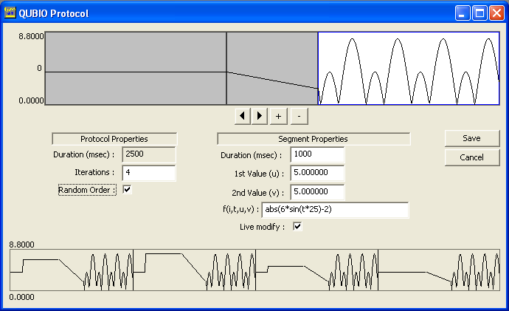

Protocols are the definition of analog data to be generated. A protocol file contains a series of segments and an iteration count. Each segment produces an output based on user settable values and functions. The Protocol Dialogue consists of a segment selection area, protocol properties, segment properties and multiple iteration display.

Segment Selection Area
The segment selection area displays the segments in the protocol. The currently selected segment has a white background and all others have a gray background. When a segment is clicked on it becomes the current segment.

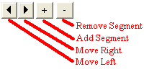
The segment selection controls can be used to move the selected segment left or right within the protocol, add a copy of the current segment as a new segment or delete the current segment if it is not the only segment in the protocol.

Protocol Properties
The protocol properties displays the total duration for the protocol and the number of iterations of the protocol. The total duration is the sum of the segment durations for the first iteration of the protocol. The number of iterations is used to cause the protocol to generate a fixed number of times and can also be used to alter the generation of each segment.
The “[ ] Random” check box will cause protocols with multiple iterations and one or more segments which have a function dependent on the iteration (i) to be issued in a random sequence. For example, if there are 4 iterations then the segment will be evaluated four times with i having the values 0.0, 0.33, 0.67, 1.0. Selecting the random option will use the same 4 values, but in a random order such as 0.33, 0.0, 1.0, 0.67.

Segment Properties
Segments can be a straight line between 2 values or a user provided function. Each segment consists of the following elements :

Duration : This is the duration of the protocol segment. This can be a function of the iteration.
1st value (u) and 2nd value (v) : If a function is not provided, these provide the starting and ending values of the segment. If a function is provided these values may be used in the function.
Live Modify : If this is checked, when the generation panel is added to the session dialogue it will contain edit boxes to modify the duration of the segment and the “1st and 2nd values” u and v if used in the function.
Function f(i,t,u,v) : This is a mathematical description of the output to be created. If no function is provided, the default function “ line(u,v) ” is used to draw a straight line.
The function is an expression composed of various mathematical symbols and four variables : i, t, u, v. The expression is evaluated repeatedly at the generation sampling rate during the generation of the protocol.
The variable ‘i' ranges from 0 to 1 as the iteration count goes from 1 to its maximum. For example If you set the iteration count to 5, this segment will be evaluated during the first iteration with i=0.0, then 0.25, 0.50, 0.75, and 1.0 for the final (5th) iteration. If there is only one iteration, the variable i should not be used.
The variable t ranges from 0 to 1 during the evaluation of the segment for each iteration. At the start of the segment t=0.0, midway through t=0.5 and at the end t=1.0.
The u and v variables correspond to the ‘1st value’ and ‘2nd value’ in the segment properties above. When these are used in the function and the live modify flag is set, these values can be modified while the segment is running. For example, if the function line(u,u) is provided to produce a pulse the level of the pulse will be changeable while the protocol is generating by changing the u parameter.
All functions must be in lowercase. The following functions can be used in the expression :
i,t,u,v : as described above
+ - * / : add , subtract, multiply , divide. Example: t*5+u/v-2
^ : exponentiation. Example t^3 is equivalent to t*t*t.
max( v1, v2) : maximum (greatest) value. Example : max(0.75,t) the greater of 0.75 and t.
min( v1, v2 ) : minimum (least) values.
sin( v1 ) : trigonometric sine() of v1. v1 is in radians.
cos( v1 ) : trigonometric cosine() of v1. v1 is in radians.
ln( v1 ) : nautral logarithm of v1. Use ln(v)/ln(10) for log base 10.
exp( v1 ) : e ^ v – exponentiation.
sgn( v1 ) : (signum) -1 for values < 0 , 0 for values = 0, +1 for values > 0.
abs( v1 ) : absolute value of v1.
line( v1,v2) : Straight line from v1 to v2. Equivalent to u*(1-t)+v*t.
ramp( frac, v1, v2, v3 ): Straight line from v1 to v2 during the first (frac) of the segment (ramp up);
straight line from v to w during the last (1-frac) fraction of the segment (ramp down).
Example : ramp(0.25,0,8,0) would ramp from 0 to 8 during the first quarter (0.25) of the segment and from 8 back to 0 during the remaining three quarters.
pulse( frac, v1, v2 ) : level v1 during the first (frac) fraction of the segment;
level v2 for the remainder.
rmpex( a, v1, v2 ) : exponential rise from v1 to v2 then fall from v2 to v1 with curvature a ( e^(at) )
hai( r, v1, t1, v2, t2, v3 ): A pulse from 0 to v then back to 0. v depends on the variable i (portion of total iterations): for i in 0..t1, the pulse rises to v1. For i in t1..t2, it rises to v2; for i in t2..1.0: v3. The pulse rises and falls on a ramp which takes r fraction of the time. (i.e. r=0.1 – ramp up and down during first and last 10 percent.)

Nearly any combination of the above may be used, such as the expression shown in the graphic above, “abs(6*sin(t*25+2))” or “5.0*sgn(v+line(u,v)+ 4^u-u/(sin(t*3)+i))”, etc.

Multiple iteration display
If the number of iterations is not large (<=100 ), the lower graphic shows the appearance of all iterations. This is useful for the display of segments which are dependent on the iteration. In the example display, the first two segments of the protocol change with each iteration. The last segment does not.
The scale of the display changes dependent on the maximum absolute value generated. The expression is evaluated once for each pixel of display and therefore may not capture extreme values.

Digital Protocol Dialogue

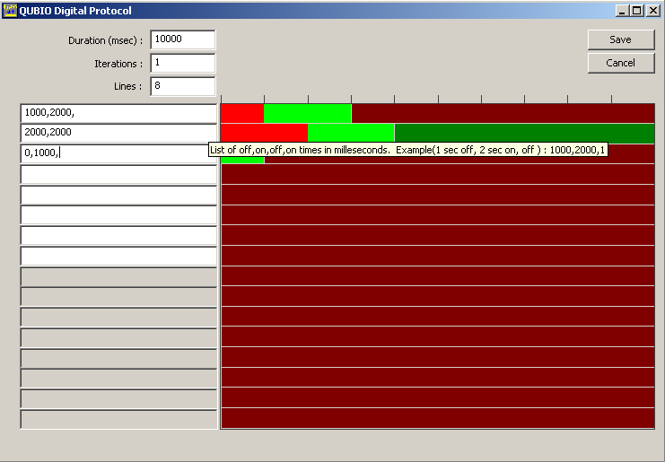
The digital protocol defines a series of on/off transitions for 1 or more digital lines. For each line you specify a series of durations in milliseconds separated by commas. The intial duration is off or low. The display shows a red for off/low periods and green for on/high periods. The Duration(msec) for the entire protocol sets the duration for all lines. Lines for which the durations do not span the full protocol duration are left in the last specified state. This is indicated in the display as a dark red or dark green area. You can click in the display to toggle the state of the line. The mouse click is interpretted to the nearest ¼ second and the corresponding text duration list is updated.
A single line from a digital protocol can also be used for analog generation of pulse trains. On the session configuration dialog, for the generation file specify : a digital protocol filename, a line number and voltage. For example, “c:\Wherever\DigPulse.qdp, 3, 4.5” would write line 4 of the specified digital protocol with pulses of 4.5 volts and baseline of 0 volts.

Session Configuration Dialogue
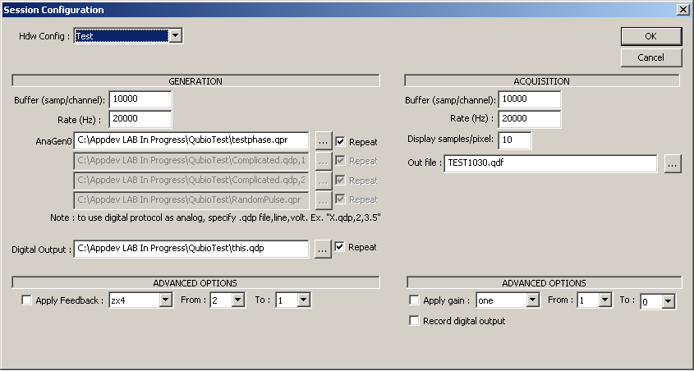
The session configuration is displayed when a new session is created, an existing session is opened, or the [Config] button is selected from the session dialogue.
Hdw Config : Select from a list of configurations. This list is maintained from the main menu “File->Hardware Config” option.
Generation
Buffer (Samp/channel) : The size of the hardware buffer allocated to the National Instruments card. Too small of a buffer can cause glitching (the hardware buffer fills and overwrites data that has not yet been processed by the program). Too large of a buffer can overflow available memory and be swapped to disk, which can be too slow for the card to utilize. A good starting value is about 2 seconds. Buffer calculation = rate(hz) X channel-count X length-in-seconds X 4(bytes per datum)
Rate (Hz) : Samples per second generated or acquired.
File names : Protocol file names to be used for generating data. The […] button opens a file selection dialogue. The “[x]Repeat” checkbox determines whether the protocol loops at the end or holds the last generated value until acquisition is terminated when all generations are run simultaneously. Individual generations can be manually run with or without repeat,r egardless of this setting.
Acquisition
Buffer (Samp/channel) : The size of the hardware buffer allocated to the NI card.
Rate (Hz) : Samples per second generated or acquired.
Display samples per pixel : Determines how many samples are aquired before the display advances 1 pixel. This can be modified while the acquisition is running.
Out file : The file name acquisition data is saved to. The […] button opens a file creation dialogue.
Generation advanced options
Apply Feedback : New feature, not yet fully tested.
Acquisition advanced options
Apply gain : New feature, not fully tested.
Record digital output : Manual digital output is recorded as list notes.
Session Dialogue
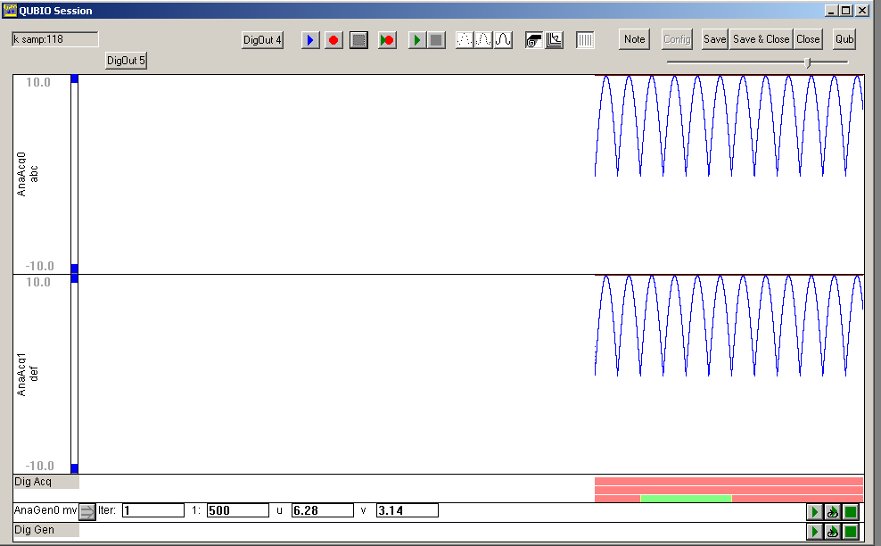

Sessions are the interface to the data acquisition / generation hardware. Acquisition and generation of data can be synchronized or independent. The session dialogue consists of control buttons, acquisition display panels, generation configuration panels and a display range scroll bar.

Control Buttons

Note: Control buttons which apply only to generation or acquisition may not appear if the session is acquisition only or generation only. This is determined by the channels in the selected hardware configuration. Control buttons will be grayed when they are not functional. i.e.: functional, not functional

Starts acquisition to the display without recording. If session is already recording, switches to play mode.
Start acquisition to the display and recording to a file. If session is already playing, starts recording mode.
Stops acquisition. This includes stopping display only, recording, or synchronized acquisition/generation modes.
Starts acquisition recording and generation of all outputs simultaneously. Acquisition and generation are tied to a common clock signal on the hardware and both occur at the Generation rate.
Starts continuous generation of all outputs. At the end of the generation, the generation for each output will either be 0 or repeat, depending on the “[ ] repeat” setting for that channel in the session configuration dialogue.
Stops generation if started by the Generate All button. Does not stop generations started with synchronized acquisition or single output generations started from the panel.

Drawing Mode : each column of pixels on the display can represent multiple samples. These buttons select a drawing mode where the first sample is plotted for each pixel column, the average of all samples for a pixel column is plotted, or each sample for a pixel column is plotted.

Scrolling Mode : These buttons select between a scrolling display similar to a chart recorder where the newest samples are always at the right of the display, and an overwrite display similar to an oscilloscope.

Time separations : toggles the display of a vertical line every 1000 samples.

Note Opens a note edit dialogue window. The note will contain the current sample time from the acquisition buffer and is initially blank. You can fill in any note text or select from a list of predefined notes. If you save the note, it will be visible in QuB as a list item. If you close the session before saving the note, the note will be destroyed.
Config Opens the session configuration dialogue : select protocols, rates and buffer sizes.
Save Saves the current session settings to a file. If the session has not been saved a filename will be requested. Otherwise the existing file will be overwritten.
Save & Close Functions the same as the [Save] and [Close] buttons combined.
Close Close the session. Settings are not automatically saved. Select [Save & Close] if you wish to save.
Qub Close the session and attempt to open the acquired data file in Qub. This is similar to selecting in the windows task bar : [Start][Run][filename to open.qdf]. If you cannot open .qdf files in this manner then the [QuB] button will not succeed either. If you have used the windows file associations to set a different program for opening .qdf files, it will be used.
Digital output buttons such as DigOut4 are displayed for digital output buttons which are set to ‘manual’ or ‘automatic’ operation. The text in the button is the name supplied in the hardware settings. These buttons may not function when continuous acquisition is active.
The slide bar determines the number of samples per display pixel. This speeds up or slows down the rate of the display, but does not affect the rate of acquisition.

Analog Acquisition Display Panels

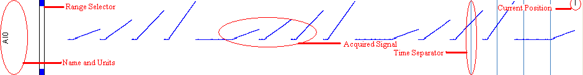

The ‘Scope’ portion of the display is a series of acquisition panels. There is one panel for each active acquisition channel in the selected hardware configuration. These panels may be resized by clicking on and dragging the left edge of the black separator between the panels. Each panel may contain the following elements :
Name and Units : Displays the name and units text from the hardware configuration.
Range Selector : The blue end points of the scroll bar can be moved with the mouse to limit the range of acquisition that is displayed in the panel. The data recorded to the disk is not affected.
Acquired Signal : The acquired data with gain and scaling applied.
Time Separator : A vertical line is drawn every 1000 samples. This can be set on or off ().
Current Position : A small vertical line on the top panel indicates the current position of the acquisition.
Recording Indicator : A single red line at the top of the scope display indicates that recording is active. During display only (play) periods, this will be white. This can be seen in the example full scope display above.

Analog Generation Configuration Panels

At the bottom of the scope display there may appear generation panels if you have any active generation channels in the selected hardware configuration. These panels allow you to control generation of individual output signals and to change the protocol settings where applicable during acquisition. Each panel may contain the following elements :
Name : Displays the name text from the hardware configuration.
Update : If the duration or parameters for the output protocol have been modified, this will write the changes to the loaded protocol. Changes will not be saved to the protocol file. If the generation is currently active, the settings to duration and parameters may not be observed until the current buffer is emptied. The length of this buffer is set in the session configuration dialogue. Changes to the duration will also not occur until the next iteration or loop of the protocol.
2: Segment : The segment number within the protocol. Only the protocol segments with “ x Live Modify” checked will appear.
1000 Duration : The duration of the segment within the protocol (milliseconds).
10.00 Parameter (s) : If the protocol segment uses a custom function which references ‘u’ or ‘v’ parameters then these parameters will be shown and modifiable.
Once : Generate the protocol one time for this channel. While this is active, no other generations can be started. Generating one time may produce multiple iterations of the protocol as specified in the protocol editor.
Loop : Generate the protocol continuously for this channel. While this is active, no other generations can be started. If the “ x repeat” box has not been checked then the generation will continue but output will be 0.
Stop : Stop a generation started in this panel.

Digital Acquisition Panel
The Digital acquisition panel will be divided into rows corresponding to the digital lines which have been set to ‘input’. During acquisition sessions, the rows will appear red when low/off and green when high/on.

Digital Generation Panel
The digital generation panel contains the same 3 buttons as the analog acquisition panel (play once, loop, stop ) but does not have the parameter or iteration options.

